**DAILY ONLINE ACTIVITIES SUMMARY**

|  |  |  |  |  |  |  |  |
| --- | --- | --- | --- | --- | --- | --- | --- |
| **Date:** | **30/06/2020** | | | | **Name:** | **Syed Rabeya Aamir** | |
| **Sem & Sec** | **8th B** | | | | **USN:** | **4AL16CS112** | |
| Online Test Summary | | | | | | | |
| **Subject** | | **___** | | | | | |
| **Max. Marks** | | **__** | | **Score** | | **---** | |
| Certification Course Summary | | | | | | | |
| **Course** | **INTRODUCTION TO INFORMATION SECURITY.** | | | | | | |
| **Certificate Provider** | | | **Great Learning** | **Duration** | | | **5.5 hrs** |
| Coding Challenges | | | | | | | |
| **Problem Statement:**  **1)**  Python program to remove Nth of the given word. | | | | | | | |
| **Status: Solved** | | | | | | | |
| **Uploaded the report in Github** | | | | **YES** | | | |
| **If yes Repository name** | | | | **rabeya** | | | |
| **Uploaded the report in slack** | | | | **YES** | | | |

**Certification Course Details:**

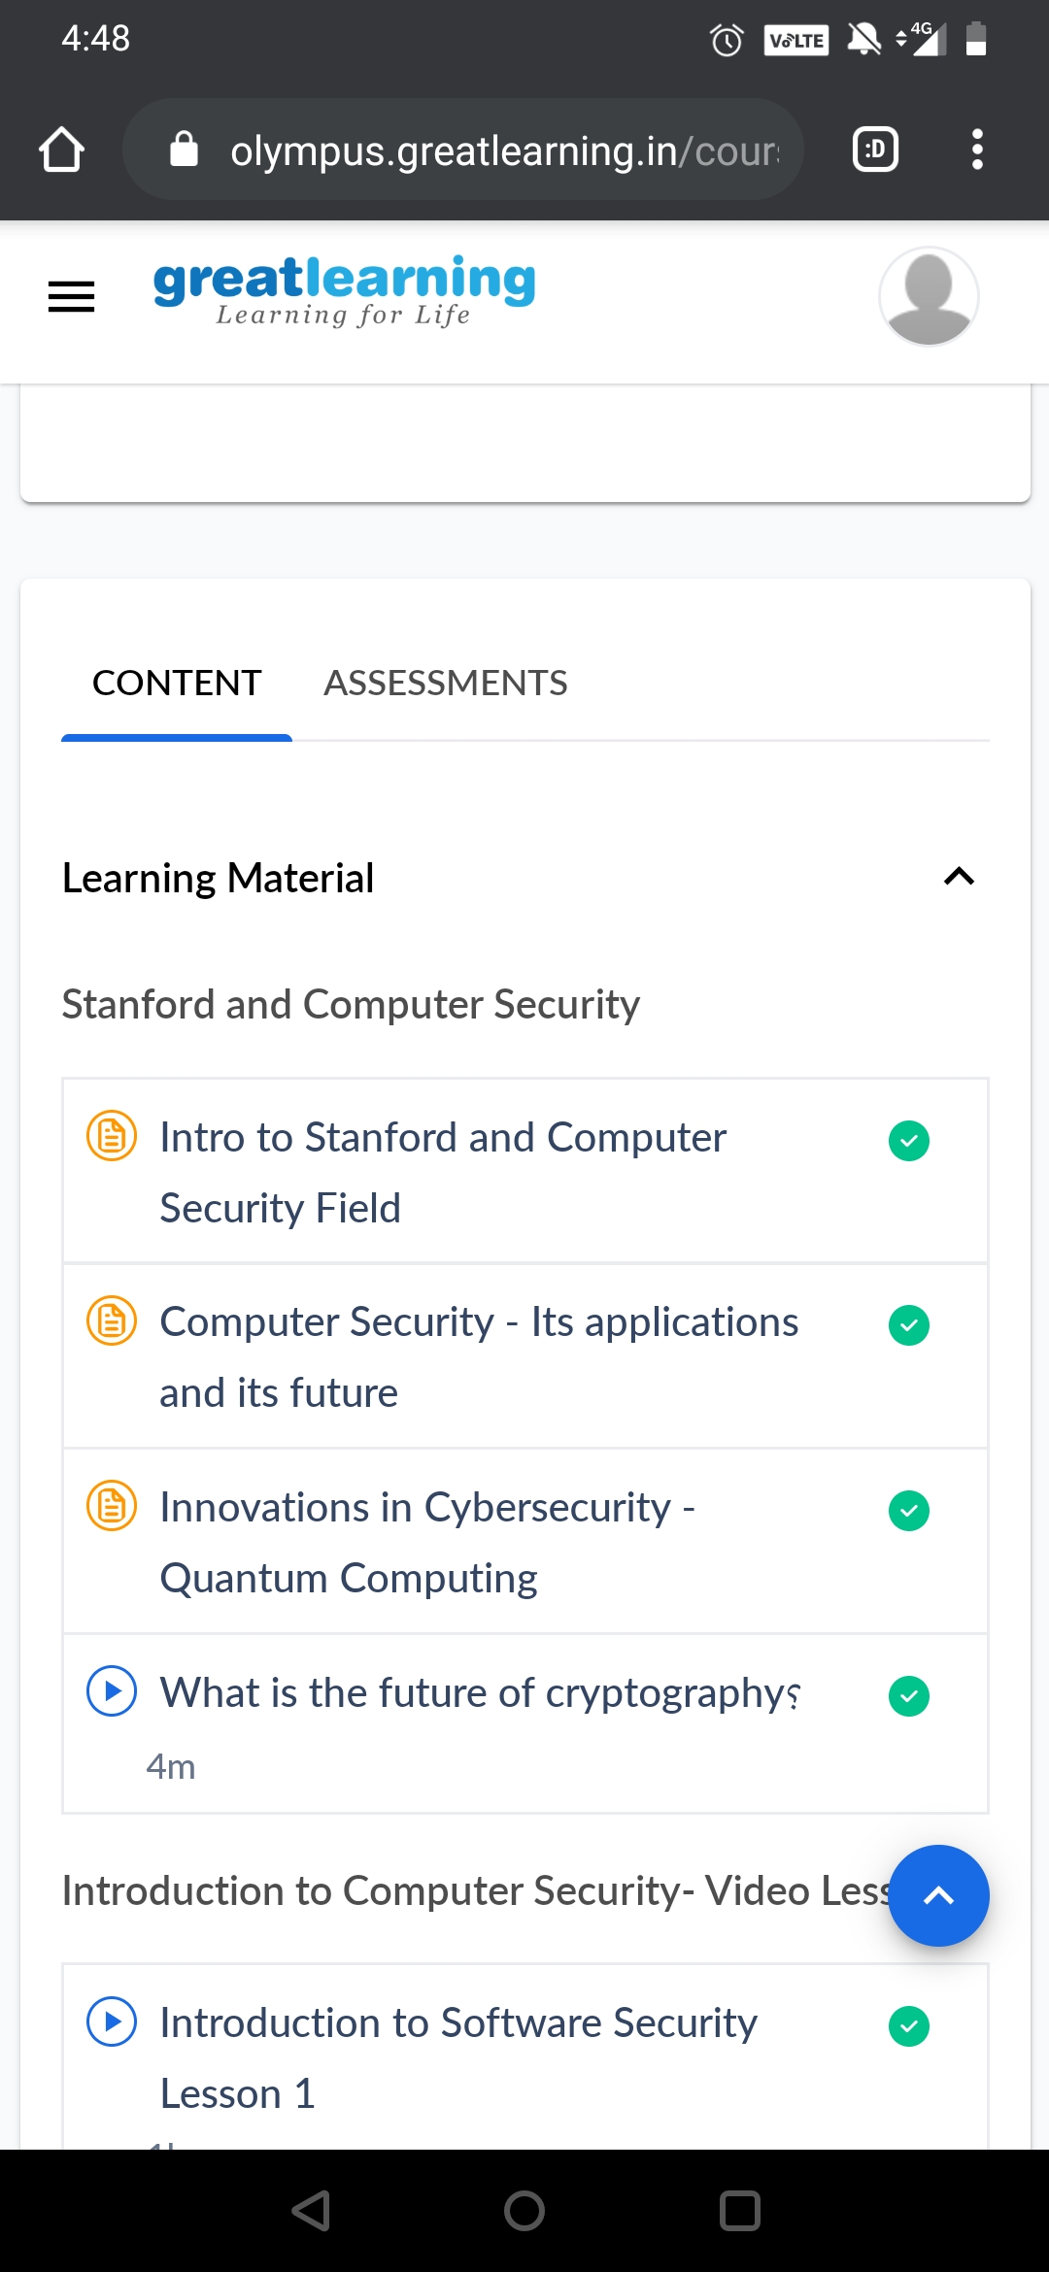

# CODE:

Program no:1

#Python program to remove Nth of the given word.

def RemoveIthWord(lst, word, N):

newList = []

count = 0

# iterate the elements

for i in lst:

if(i == word):

count = count + 1

if(count != N):

newList.append(i)

else:

newList.append(i)

lst = newList

if count == 0:

print("Item not found")

else:

print("Updated list is: ", lst)

return newList

# Driver code

list = ["geeks", "for", "geeks"]

word = "geeks"

N = 2

RemoveIthWord(list, word, N)